

|  |  |  |  |
| --- | --- | --- | --- |
| Year 11 Human Biology – Topic Test (Task 13)  **Types of Inheritance (3%)** | | | |
|  | | | |
| Name: | | | |
| Time allowed: 55 Minutes | | | |
| **Section** | Your Mark | Marks available | Percentage of Investigation |
| **Multiple Choice** |  | 17 | 28% |
| **Short Answer** |  | 33 | 55% |
| **Extended Response** |  | 10 | 17% |
|  |  | **60** | **100%** |

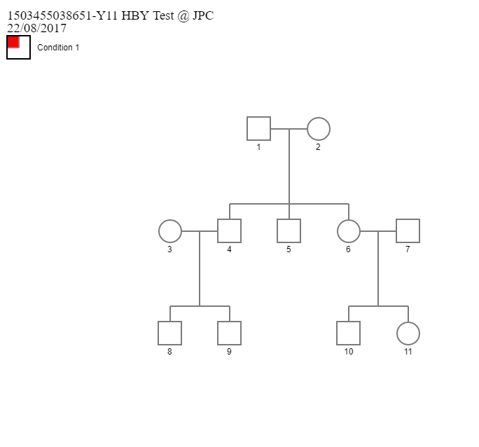The following diagram shows the inheritance pattern of the recessive trait; red hair.

1. Deduce the genotypes of individuals numbered 7 and 9.
2. HH and hh
3. Hh and Hh
4. hh and hh
5. Hh and hh
6. Red-green colour-blindess is an X-linked recessive disorder. A father with this condition will pass this allele on:
7. all his children
8. his sons only
9. none of his children
10. his daughters only
11. The main distinction between autosomal and sex chromosomes is that:
12. autosomal chromosomes carry more dominant alleles than sex chromosomes
13. sex chromosomes only have genes which determine the sex of an individual whereas autosomal chromosomes carry genes which control all the other traits
14. sex chromosomes determine the sex of an individual, autosomal chromosomes do not
15. sex chromosomes have recessive genes, autosomal chromosomes have dominant genes

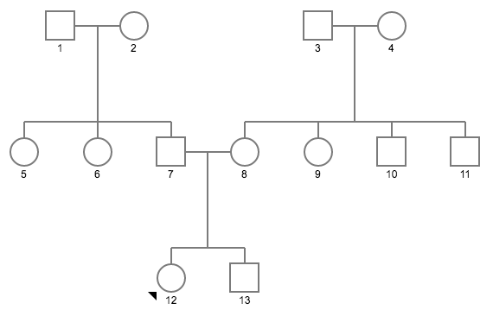The next three questions (4-6) refer to the following pedigree showing the inheritance of a single-gene genetic disorder.

1. From this pedigree, it appears that the grandparents:
2. each carry an allele for the disorder
3. at least one of each grandparent couple carries a gene for the disease
4. are all homozygous
5. only one couple is homozygous
6. only one couple is homozygous
7. It can be concluded that the shaded characteristic is determined by:
8. an autosomal recessive gene
9. an autosomal dominant gene
10. an X-linked recessive gene
11. an X-linked dominant gene
12. If female 5 is a carrier and she marries a homozygous normal male, what are her chances of producing a child who has the genetic disorder?
13. 0
14. 25%
15. 50%
16. 100%

1. Colour blindness is an X-linked recessive condition. What is the probability that a man who is colour blind who is married to a woman who is a carrier, have a child who is colour blind?
2. 0.25
3. 0.50
4. 0.75
5. 1
6. In humans, a male baby results when:
7. The egg is fertilized by a sperm carrying a Y chromosome
8. The egg is fertilized by an X chromosome
9. The unfertilized egg contains a Y chromosome
10. The egg is fertilized very early in the menstrual cycle
11. If a woman with blood group AB marries a man with blood group O, what are the chances of the first child having blood group B?
12. 0%
13. 25%
14. 50%
15. 75%
16. Cystic fibrosis is an autosomal recessive disease. A married couple are both carriers of this disease. If they have a child, what is the probability that the child will be born with the disease?
17. 0%
18. 25%
19. 50%
20. 75%
21. An allele is best defined as
22. A representation of a genotype
23. Two chromosomes that are the same length and code for the same traits
24. The basic unit of heredity
25. An alternative form of a gene located on the chromosome
26. If a gorilla has 22 pairs of chromosomes in a skin cell, how many chromosomes are there in the gorilla’s sperm?
27. 11 chromosomes
28. 11 pairs of chromosomes
29. 22 chromosomes
30. 22 pairs of chromosomes

The next question refers to the pedigree below showing the inheritance of a recessive trait.



1. Which one of the following alternative lists individuals in this pedigree who are definitely heterozygous for the recessive characteristic?
2. 1, 2 and 7
3. 3, 6 and 7
4. 1, 3 and 6
5. 1, 5 and 6
6. If a cell was removed from the inside cheek of a woman, what would a scientist be able to identify?
7. 22 autosome pairs plus the XY sex chromosomes
8. 22 sex chromosome pairs plus the XX autosomes
9. 22 autosome pairs plus the XX sex chromosomes
10. 22 sex chromosomes pairs plus the XY autosomes
11. In the ABO blood group system in humans, if a person of type B blood has children with a person of type-AB blood, what blood types could their children have?
12. Type AB, type A and type B
13. Type B and type AB
14. Type AB, type A, type B and type O
15. Type A and type B
16. What was the most significant conclusion that Gregor Mendel drew from his experiments with Pea Plants?
17. There is considerable genetic variation in pea plants
18. Inherited characteristics were controlled by factors that occurred in pairs
19. Recessive genes occur more frequently in the F1 than dominant genes
20. Genes are composed of DNA

The next question refers to the diagram below showing the DNA fingerprints produced as evidence in a case in which a man is suspected of committing murder.



1. It can be concluded from the information provided that the suspect was at the scene of the crime because the...
2. Blood on the suspect’s shoes matches that of the victim
3. Suspect’s DNA and the blood on his shoes matches that of the victim
4. Suspect’s DNA does not match that of the victim
5. Blood on the suspects shoes does not match his own DNA

**Short Answer Questions (33 Marks)**

1. Snapdragons are a type of flower. When a homozygous red snapdragon is crossed with a homozygous white snapdragon all the offspring were pink snap dragons.
2. Show this **cross** and **state** the name for this type of inheritance**.** **(2 marks)**

Incomplete Dominance (1)

|  |  |  |
| --- | --- | --- |
|  | FR | FR |
| FW | FR FW | FR FW |
| FW | FR FW | FR FW |

(1)

1. Plants from the first filial (F1) above were crossed to create the second filial (F2). What would be the expected **phenotypes** and **genotypes** of the second filial? Show your working out. **(2 marks)**

|  |  |  |
| --- | --- | --- |
|  | FR | FW |
| FR | FR FR | FR FW |
| FW | FR FW | FW FW |

25 % Red, 25% White, 50% Pink (1)

1. Complete the following table by filling in the blank white spaces. **(3 marks)** *(1/2 mark each box)*

|  |  |  |  |
| --- | --- | --- | --- |
| **Genetic Disorder** | **Mode of Inheritance** | **Characteristics** | **Symptoms** |
| Huntington’s disease | Autosomal Dominant | Breakdown of nerve cells in the brain. | * Involuntary jerking * Slow or abnormal eye movements * Difficulty with the physical production of speech or swallowing |
| Phenylketonuria (PKU) | Autosomal Recessive | Buildup of toxic phenylalanine resulting in damage to the brain. | * Musty odor in the breath, skin or urine * Skin rashes * Seizures * Delayed movements |
| Duchene muscular dystrophy | X linked recessive | Wasting of muscles normally from the legs first. | * Trouble walking * Poor posture * Bone thinning * Breathing difficulties |
| Red green colour blindness | X linked Recessive | Inability to discriminate between red and green |  |

1. A married couple have three children who have free ear lobes (autosomal dominant), and one child that has attached ear lobes (autosomal recessive). What are the most likely genotypes of the parents? **Justify** your answer and show your working.

**(3 marks)**

Parents must both be heterozygous for the condition. (1)

Children receive one gene from each parent – therefore to get the recessive condition, they need both parents to pass on a recessive gene. (1)

|  |  |  |
| --- | --- | --- |
|  | E | e |
| E | EE | Ee |
| e | Ee | ee |

1. – shows Punnet Square.
2. Mr. and Mrs. Allan both have type A blood. Mrs. Allan gives birth to a baby girl who is mixed up with two other new born girls in the crowded hospital nursery. Baby 1 has type B blood. Baby 2 has type A blood. Baby 3 has type AB blood. Which baby belongs to the Alans? Give evidence from possible genotype pairings.

**(4 marks)**

1 mark per Punnet Square:

|  |  |  |
| --- | --- | --- |
|  | IA | i |
| IA | IA IA | IAi |
| i | IAi | ii |

|  |  |  |
| --- | --- | --- |
|  | IA | IA |
| IA | IA IA | IA IA |
| IA | IA IA | IA IA |

|  |  |  |
| --- | --- | --- |
|  | IA | i |
| IA | IA IA | IAi |
| IA | IA IA | IAi |

Their parents can only produce a child with A or O blood type.   
Therefore, the child must be Baby 2.

1. **Describe** the difference between codominance and incomplete dominance **give one example of each.**  **(4 marks)**

**Incomplete dominance**

* one allele for a specific trait does not completely dominate over the other allele; therefore, the phenotype expressed is a blend of both dominant and recessive alleles.
* Credible example: e.g. a homozygous white flower crossed with a homozygous red flower results in all the offspring being pink flowers.

**Codominance**

* Both alleles for a specific trait are equally expressed and not blended.
* Credible example: e.g. a cross between a homozygous black cat and a homozygous white cat results in the offspring being white with black spots

1. Alan is married to Beatrice. They have five children born in the following order; Cheryl, Douglas, Edward, Frederick and George. George and Cheryl are born with Haemophilia, none of the other siblings have it. Cheryl is married to Henry and George is married to Isabelle. Cheryl and Henry have one daughter (Julie) and one son (Tom). Leonard and Martin are brothers. Their mother is Isabelle who is not a carrier of haemophilia.
2. **Draw** a correct pedigree showing the inheritance of haemophilia from the following information.  **(4 marks)**

1 mark – drew connections correctly.

1 mark – coloured Cheryl and George

1 mark – coloured Alan

1 mark – coloured Tom



1. Is it possible for Leonard or Martin to be carriers of haemophilia? **Explain** your answer. **(2 marks)**

No.   
Haemophilia is an X-linked disease, as boys only have one X-chromosomes, if they have the gene, then they have the disease. They cannot be carriers.

1. The photograph below shows the equipment used in the process of electrophoresis which is used in DNA profiling.



1. **State** what electrophoresis does and **explain** how it works. **(4 marks)**

* It separates DNA strand by their length
* DNA strands are negatively charged due to their phosphate groups
* The strands move through the gel attracted to the positive charge at the end
* The smaller the DNA the faster it moves, the larger the DNA the slower it moves.

1. State the name of the enzyme used to cut the DNA up into smaller fragments?

**(1 mark)**

Restrictive Enzyme.

1. Compare single gene disorders and multifactorial genetic disorders and give an example of both. **(4 marks)**

* Single Gene Disorder - When a certain **gene** is known to cause a disease
* Example: Cystic fibrosis, Tay-sachs
* Multifactorial gene disorder - The factors are usually both genetic and environmental
* Example: heart disease, diabetes, cancers

**Extended Response: (10 marks)**

*Write your answer on the lined paper provided.*

Malaria is a parasitic disease widespread in the tropics and transmitted by mosquitos. Sickle-cell anaemia is a recessive genetic disorder found in a relatively high proportion (up to 40%) of people from tropical Africa and from countries around the Western Indian Ocean. People carrying a single copy of the gene, are generally healthy and less susceptible to malaria than people who do not carry the disease. People who are homozygous for the gene are also less susceptible to malaria, but develop a form of anaemia that is almost always fatal.

Imagine you are a genetic counsellor dealing with a coupled in one the countries above. A couple wanting to have a family present for advice. Both are known to be heterozygous for the sickle cell gene. Calculate the percentages of the likely genotypes of their children, and describe the phenotypes and survival prospects of these possible offspring.

**(10 marks)**

|  |  |  |
| --- | --- | --- |
|  | S | s |
| S | SS | Ss |
| s | Ss | ss |

Genotypes:

25% SS

50% Ss

25% ss

Phenotypes:

25% normal red blood cells/normal haemoglobin

50% Sickle cell trait/cells sickle with lack of oxygen

25% have sickled red blood cells/misinformed haemoglobin

25% chance the child will be fine but more likely to catch malaria

50% chance the child will be fine, and less likely to catch malaria

25% that the child will have sickle cell disease and die but also be protected from malaria